SHANCHITA – Team Profile

# Background of Team Members

### Humaira Aziz

With 20+ years of experience, Humaira Aziz has led numerous projects on Violence against Women and Girls, Dignified Work, Livelihood and Economic Empowerment of Women. Currently, as the Director of Women’s Economic Empowerment Program of CARE Bangladesh, she oversees projects that have worked with over 130,000 garment workers. A life-long advocate of women’s empowerment, her technical expertise lies in the areas of health, livelihood, gender, partnership, advocacy, communications and training.

Role in team: Technical information and content of Shanchita App. Partnerships with RMG factories and Banking Institutions. Resource mobilizing strategy.

Special requirements (Accommodation, translation or others): None

### Mahadi Hassan

With over 8 years of experience, from healthcare research background to Monitoring & Evaluation (M&E) in current role, Mahadi Hassan brings project management, monitoring, financial management and partnership development across sectors. Working as the M&E focal across 6 projects simultaneously allows Mahadi to look at the impact and results of women’s economic empowerment across different approaches.

Role in team: Gathering evidence of impact and results in financial service usage behavior. Analyzing impact of change on women’s economic empowerment. Partnership development and linking pitches with actors in RMG Sector and Financial Institutions. Tracing result of using Shanchita App to behavioral changes.

Special requirements (Accommodation, translation or others): None

### Albaab-ur-Rahman

Starting in the private sector working for a major Multi-National Corporation, Albaab moved into development sector as a Value Chain specialist, with work in making markets work for the poor. Currently, in CARE Bangladesh, he is institutionalizing Knowledge Management & Learning. For all 3 Cohorts of Scale X Design, he developed the applications and assisted in subsequent pitch development, where 5 pitches were finalists and 3 were awarded.

Role in Team: Developing business plan, Scale X Design accelerator process, interpreting impacts in business context for market-centric audience.

# Shanchita App

Photos of App Pages

## Project Objective (69 words)

Increase uptake of Shanchita Financial Literacy App leading to women exercising greater control and ownership over their income.

Uptake Increase objectives:

1. Domestically assembled smartphones installing Shanchita as built-in app
2. Social media marketing to increase awareness, trial and usage
3. Promoting Shanchita among other financial inclusion projects working in the area (4 identified till now)
4. Going global – Bangla App for the 7th most common language spoken globally

## Project Description (195 words)

Shanchita was developed from a financial inclusion project for RMG workers funded by VISA Worldwide Ltd in partnership with a local banking partner and 5 garment factories. The pilot was tested with ~1000 women and the change was so compelling that it is set to be further expanded to 26,000 in just one year– backed by some of the largest garment producers globally– GAP, WALMART and TARGET USA.

However, the RMG sector alone has 2.8m workers, 80% of whom are women and the current approach would be too resource-intensive to scale to millions.

Thus, the idea of turning the model to an offline android application was born. Now, why android?

* Bangladesh – Among largest user base globally: 140m mobile users, 80m using internet
* Smartphone penetration growing at 57.44% annually (1.5 times)
* Bangladesh accounts for 8% of total mobile bank accounts *globally*
* Smartphone usage to reach 60% by 2020 - fastest, cheapest way to reach mass population with targeted messaging

The App has 6 modules based on:

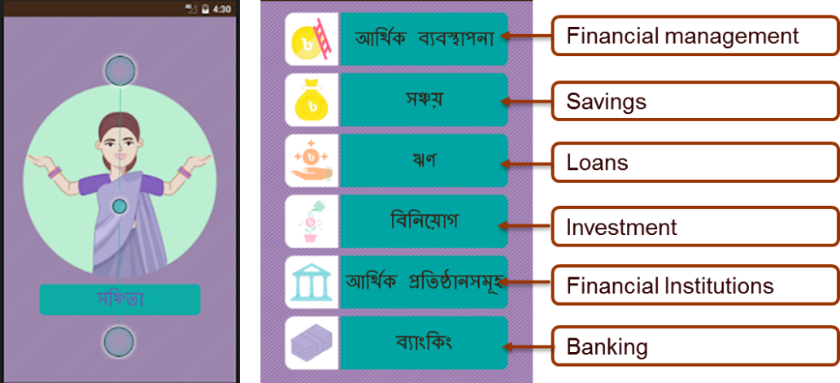Each section has necessary information and exercises (quiz) to clear understanding. In addition, each section also has audio narration, explaining complex processes through simple storytelling for those who cannot read.

## Progress made to date (184 words)

As mentioned above, this particular approach to financial inclusion of women for economic empowerment is already set to scale by 26 times.

However, the progress on downloads have been low (under 100). The app is being promoted across other CARE Bangladesh projects working with the same group. Mr. Amdadul is the Executive Director, Marketing, of Walton – the largest local brand of smartphone. He revealed their brand is hotly competitive with imported brands which are cheaper. He responded with interest to be involved once benefits to brand value perception of Walton will be proven.

Bank Asia, the local banking partner of the pilot project is working with Swisscontact in similar approach with 2,000 workers and so are a 3 other projects with RMG sectors, the App can be promoted among them to increase uptake. They have been approached with positive interest in response; but apprehensions of slight differences in approach in the app itself along with some outdated information shared.

CARE Web App, creator of the app, is interested in updating information and maintaining the app, but requires payment for services rendered over the long-term.

## Accelerator Outcomes (57 words)

* Social marketing strategy and capacity for app-based projects
* Revenue generation plan around the application, to fund its maintenance and updating
* Design and content changes to increase uptake and usage of Shanchita – User-centric design
* USP and value proposition for various target customers (RMG factories, phone company and banking institutions)
* Measuring impact of app usage on users’ financial behavior

## Moving Forward (46 words)

* Incorporating app promotion in HALOW+, a health project of CARE Bangladesh for female RMG workers
* Aiming for 10,000+ downloads in 2 years
* Powerpoint pitch created and presented to potential funders
* Identifying App gaps and updating needs for Version 2
* Release funding for WALMART project this month

INNOVATION

1. Background Documents

Relevant Documents are found in this dropbox folder: <https://www.dropbox.com/sh/emt5maw2nasung5/AACzz6tw-SvgEoQ5roaYa5oMa?dl=0>

2. Current Accomplishments in scaling?

As mentioned above, this particular approach to financial inclusion of women for economic empowerment is already set to scale by 26 times.

However, the progress on downloads have been low (under 100). The app is being promoted across other CARE Bangladesh projects working with the same group. Mr. Amdadul is the Executive Director, Marketing, of Walton – the largest local brand of smartphone. He revealed their brand is hotly competitive with imported brands which are cheaper. He responded with interest to be involved once benefits to brand value perception of Walton will be proven.

Bank Asia, the local banking partner of the pilot project is working with Swisscontact in similar approach with 2,000 workers and so are a 3 other projects with RMG sectors, the App can be promoted among them to increase uptake. They have been approached with positive interest in response; but apprehensions of slight differences in approach in the app itself along with some outdated information shared.

CARE Web App, creator of the app, is interested in updating information and maintaining the app, but requires payment for services rendered over the long-term.

3. Team goals for scaling?

In-built app for an OEM, either Walton or some other company

4. Scaling 5 years from now

100,000 Downloads. Inclusion model being replicated physically in 20 of largest factories

5. Additional Barriers?

Other financial literacy apps in the market. New nature of the concept creates additional resistance.

6. Priority of learning new information or new set of skills that would help to take innovation to scale?

* Social media marketing and promotion
* App development and programming skills – to make maintenance an in-house process
* Tracking user behavior in app or as a result of using an app
* Business promotion of virtual products

7. Requirement of mentor?

The following qualities of a mentor would be helpful:

* Monetization of smartphone applications
* Evaluating impact of smartphone applications
* Prior experience of working with OEMs or smartphone manufacturers
* Financial inclusion through internet
* Connections with developers, smartphone manufacturers and banking institutions

8. Requirement from a consultant or vendor support?

* Assistance in negotiating contract with smartphone manufacturer
* Linking app with banking institutions
* Monetization strategy OR self-sustaining plan for maintenance of app for the foreseeable future

9. Anything else?

Nothing specific at the moment. Queries will arise as we go through the exercises.